**System Requirements Specification Index**

**For Machine learning Algorithm No 6**

1.0

**Machine Learning usecase: Decision Trees and Random Forests**

**Heart Disease and Chicken Disease Prediction**

**Overview**

**This assessment focuses on implementing two machine learning models for disease prediction:**

1. Heart Disease Prediction using a Random Forest Classifier

2. Chicken Disease Prediction using a Decision Tree Classifier

You will implement code that provides functionality for data loading, preprocessing, model training, and prediction. The goal is to understand the core concepts of data preprocessing, model training, and evaluation for classification tasks.

**Datasets information**

1. Heart Disease Dataset (`heart.csv`)

This dataset contains medical information for 303 patients, with a target variable indicating the presence of heart disease.

Features:

- `age`: Age in years

- `sex`: Sex (1 = male, 0 = female)

- `cp`: Chest pain type (0-3)

- `trestbps`: Resting blood pressure (in mm Hg)

- `chol`: Serum cholesterol in mg/dl

- `fbs`: Fasting blood sugar > 120 mg/dl (1 = true, 0 = false)

- `restecg`: Resting electrocardiographic results (0-2)

- `thalach`: Maximum heart rate achieved

- `exang`: Exercise induced angina (1 = yes, 0 = no)

- `oldpeak`: ST depression induced by exercise relative to rest

- `slope`: Slope of the peak exercise ST segment

- `ca`: Number of major vessels colored by fluoroscopy (0-3)

- `thal`: Thalassemia (3 = normal, 6 = fixed defect, 7 = reversible defect)

Target:

- `target`: Presence of heart disease (1 = yes, 0 = no)

2. Chicken Disease Dataset (`chicken_disease_data.csv`)

This dataset contains information about 1000 chickens, with features related to their health and a target variable indicating disease status.

Features:

- `Age`: Age of the chicken in years

- `Weight`: Weight of the chicken in kg

- `Height`: Height of the chicken in cm

- `Egg Production`: Number of eggs produced per week

- `Feed Consumption`: Amount of feed consumed in kg per week

- `Temperature`: Body temperature in Celsius

- `Disease Predicted`: Disease status (Healthy or Diseased)

**Tasks**

**Task 1: Heart Disease Prediction**

You will implement the following functions in `heart.py`:

1. `load_heart_disease_data()`: Load the heart disease dataset

   - Load the CSV file "heart.csv"

   - Print confirmation message with the number of records loaded

   - Return the loaded DataFrame

2. `preprocess_heart_data(df)`: Preprocess the heart disease data

   - Separate features (X) and target (y)

   - X should contain all columns except "target"

   - y should contain only the "target" column

   - Print confirmation message

   - Return X and y

3. `split_heart_data(X, y, test_size=0.2)`: Split the data into training and testing sets

   - Use train_test_split with test_size=0.2 and random_state=42

   - Print confirmation message with the size of training and testing sets

   - Return X_train, X_test, y_train, y_test

4. `create_model(n_estimators=100, max_depth=None)`: Create a Random Forest model

   - Create a RandomForestClassifier with specified parameters and random_state=42

   - Print confirmation message

   - Return the model

5. `train_model(model, X_train, y_train)`: Train the model

   - Fit the model to the training data

   - Print confirmation message

   - Return the trained model

6. `save_model(model, filename="random_forest_heart_model.pkl")`: Save the model

   - Save the model to the specified filename using joblib.dump

   - Print confirmation message

7. `load_model(filename="random_forest_heart_model.pkl")`: Load the model

   - Load the model from the specified filename using joblib.load

   - Print confirmation message

   - Return the loaded model

8. `make_prediction(model, X_sample, source_label="")`: Make a prediction

   - Make a prediction using the model and the provided sample

   - Print the sample input and the prediction result

   - Format the prediction as " Heart Disease" or " No Heart Disease"

**Expected Output Format:**

Loading dataset...

Loaded xxx records.

Preprocessing data...

Features and target separated.

Splitting data...

Train: x42, Test: x1

Creating Random Forest model...

Training model...

Training complete.

Saving model as 'random_forest_heart_model.pkl'...

Model saved.

You as the test taker have to take first person data from the dataset to check for heart disease

**Making prediction on FIRST PATIENT in dataset...**

Sample Input:

age  sex  cp  trestbps  chol  fbs  restecg  thalach  exang  oldpeak  slope  ca  thal

 63    1   3       145   233    1        0      150      0      2.3      0   0     1

Prediction: x --> Heart Disease or Not

**Task 2: Chicken Disease Prediction**

You will implement the following functions in `chicken.py`:

1. `load_chicken_disease_data()`: Load the chicken disease dataset

   - Load the CSV file "chicken_disease_data.csv"

   - Limit to 1000 rows

   - Print confirmation message with the number of records loaded

   - Return the loaded DataFrame

2. `perform_eda_on_age(df)`: Perform exploratory data analysis on the Age column

   - Count chickens with age > 2

   - Print the count

   - Return nothing

3. `preprocess_chicken_data(df)`: Preprocess the chicken disease data

   - Convert categorical features to dummy variables using pd.get_dummies with drop_first=True

   - Verify that "Disease Predicted_Healthy" column exists after encoding

   - Separate features (X), target (y), and keep the encoded DataFrame

   - X should contain all columns except "Disease Predicted_Healthy"

   - y should contain only the "Disease Predicted_Healthy" column

   - Print confirmation message

   - Return X, y, and the encoded DataFrame

4. `split_chicken_data(X, y, test_size=0.2)`: Split the data into training and testing sets

   - Use train_test_split with test_size=0.2 and random_state=42

   - Print confirmation message with the size of training and testing sets

   - Return X_train, X_test, y_train, y_test

5. `create_and_train_model(X_train, y_train)`: Create and train a Decision Tree model

   - Create a DecisionTreeClassifier with random_state=42

   - Fit the model to the training data

   - Print confirmation message

   - Return the trained model

6. `make_predictions(model, df_encoded, original_df)`: Make predictions

   - Make a prediction for the first chicken in the dataset

   - Print the original chicken data and the prediction result

   - Format the prediction as "Healthy" or "Diseased"

7. `calculate_entropy(y)`: Calculate the entropy of the target column

   - Calculate entropy using the formula: -sum(p * log2(p))

   - Print the entropy value

   - Return nothing

**Running the Tests**

To run the tests, use the following command:

Python3 -m unittest

**Submission Guidelines**

1. Complete all the required functions in `heart.py` and `chicken.py`

2. Ensure all tests pass

3. Submit your code files

**Execution Steps to Follow:**

* + All actions like build, compile, running application, running test cases will be through Command Terminal.
  + To open the command terminal the test takers, need to go to Application menu (Three horizontal lines at left top) -> Terminal -> New Terminal
  + This editor Auto Saves the code
  + If you want to exit(logout) and continue the coding later anytime (using Save & Exit option on Assessment Landing Page) then you need to use **CTRL+Shift+B** -command compulsorily on code IDE. This will push or save the updated contents in the internal git/repository. Else the code will not be available in the next login.
  + These are time bound assessments the timer would stop if you logout and while logging in back using the same credentials the timer would resume from the same time it was stopped from the previous logout.
  + To setup environment:

You can run the application without importing any packages

* + To launch application:
  + **Python3 heart.py` and `python3 chicken.py`**
  + To run Test cases:

**python3 -m unittest**

* + Before Final Submission also, you need to use **CTRL+Shift+B** - command compulsorily on code IDE, before final submission as well. This will push or save the updated contents in the internal git/repository, and will be used to evaluate the code quality.

**Screen shot to run the program**

**To run the application**



**Python3 heart.py**

**python3 chicken.py`**

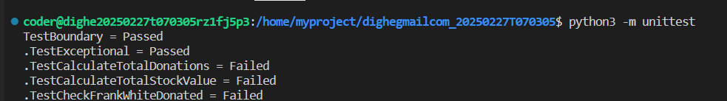

**To run the testcase python3 -m unittest**

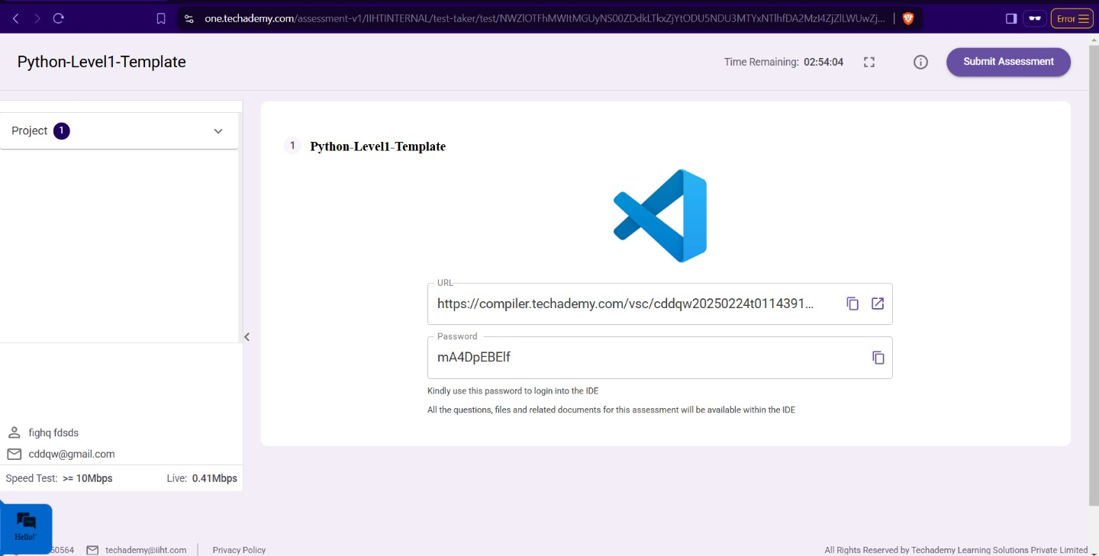

* + **Once you are done with development and ready with submission, you may navigate to the previous tab and submit the workspace. It is mandatory to click on “Submit Assessment” after you are done with code.**